ENCORE IMAGE LED PAGE GUIDE

L Oreal Colour Trophy 2026 Image Led Case Study and Page Layout Guide
Platinum Anniversary Production Celebrating 70 Years
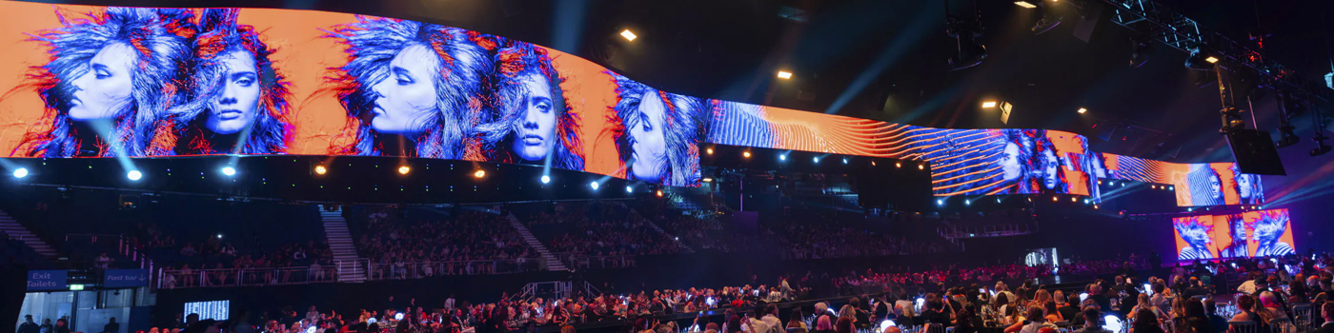
Recommended hero image
The page should feel like a visual case study. Let the photography establish scale, atmosphere and craft; use concise copy to explain the decisions behind the work.

01 VISUAL DIRECTION

Image Led Creative Direction
The strongest version of this page will be image-first rather than text-first. Each major section should give an image most of the viewport, with the copy working as an editorial layer: a short introduction, a clear point of view and a compact service list.
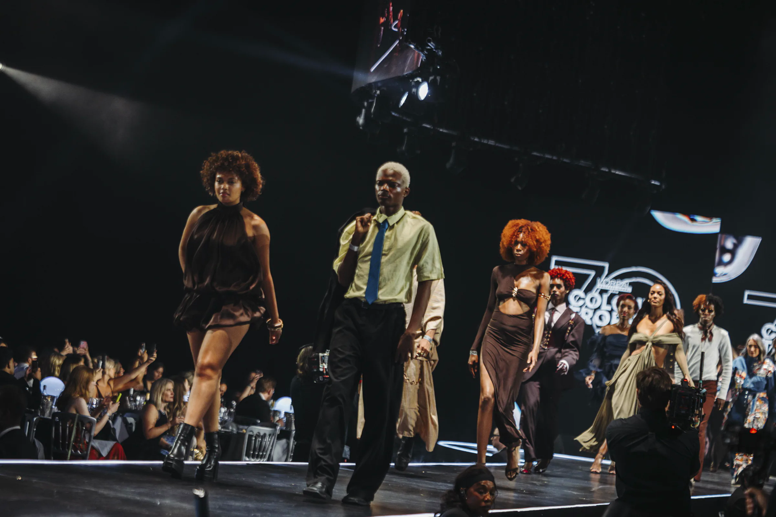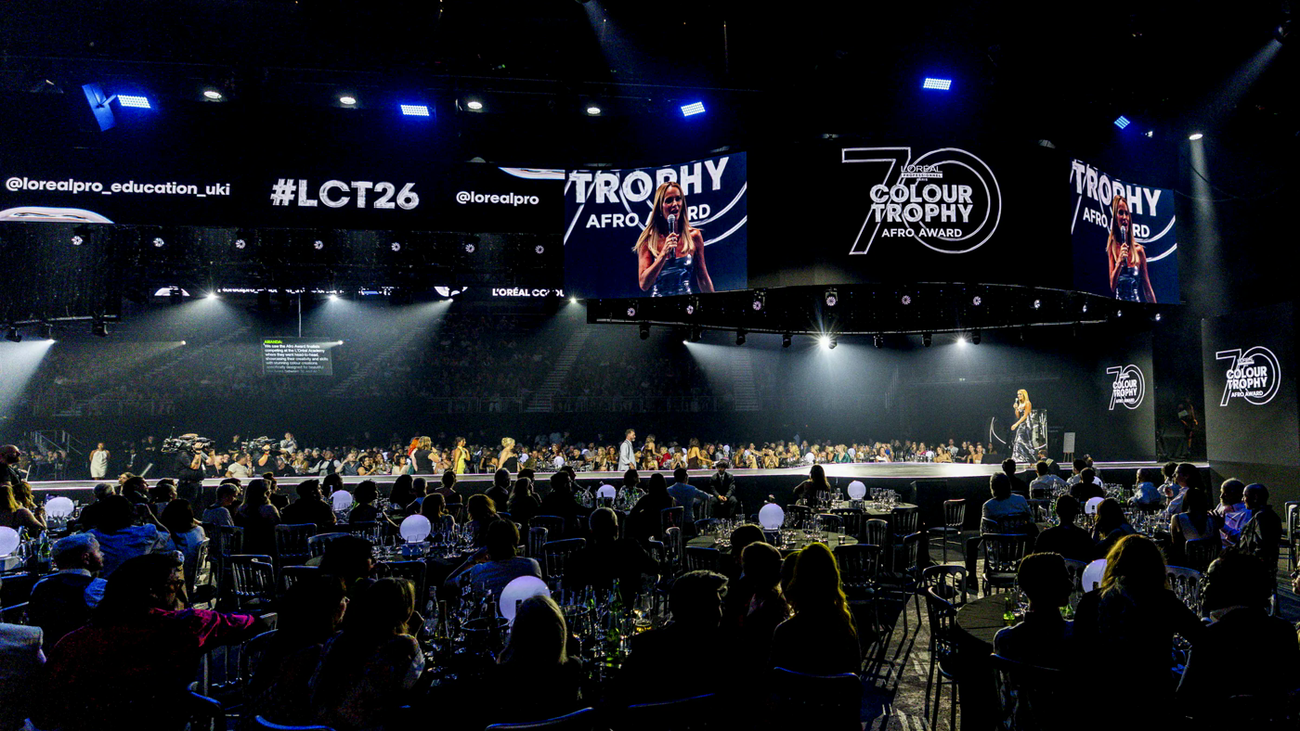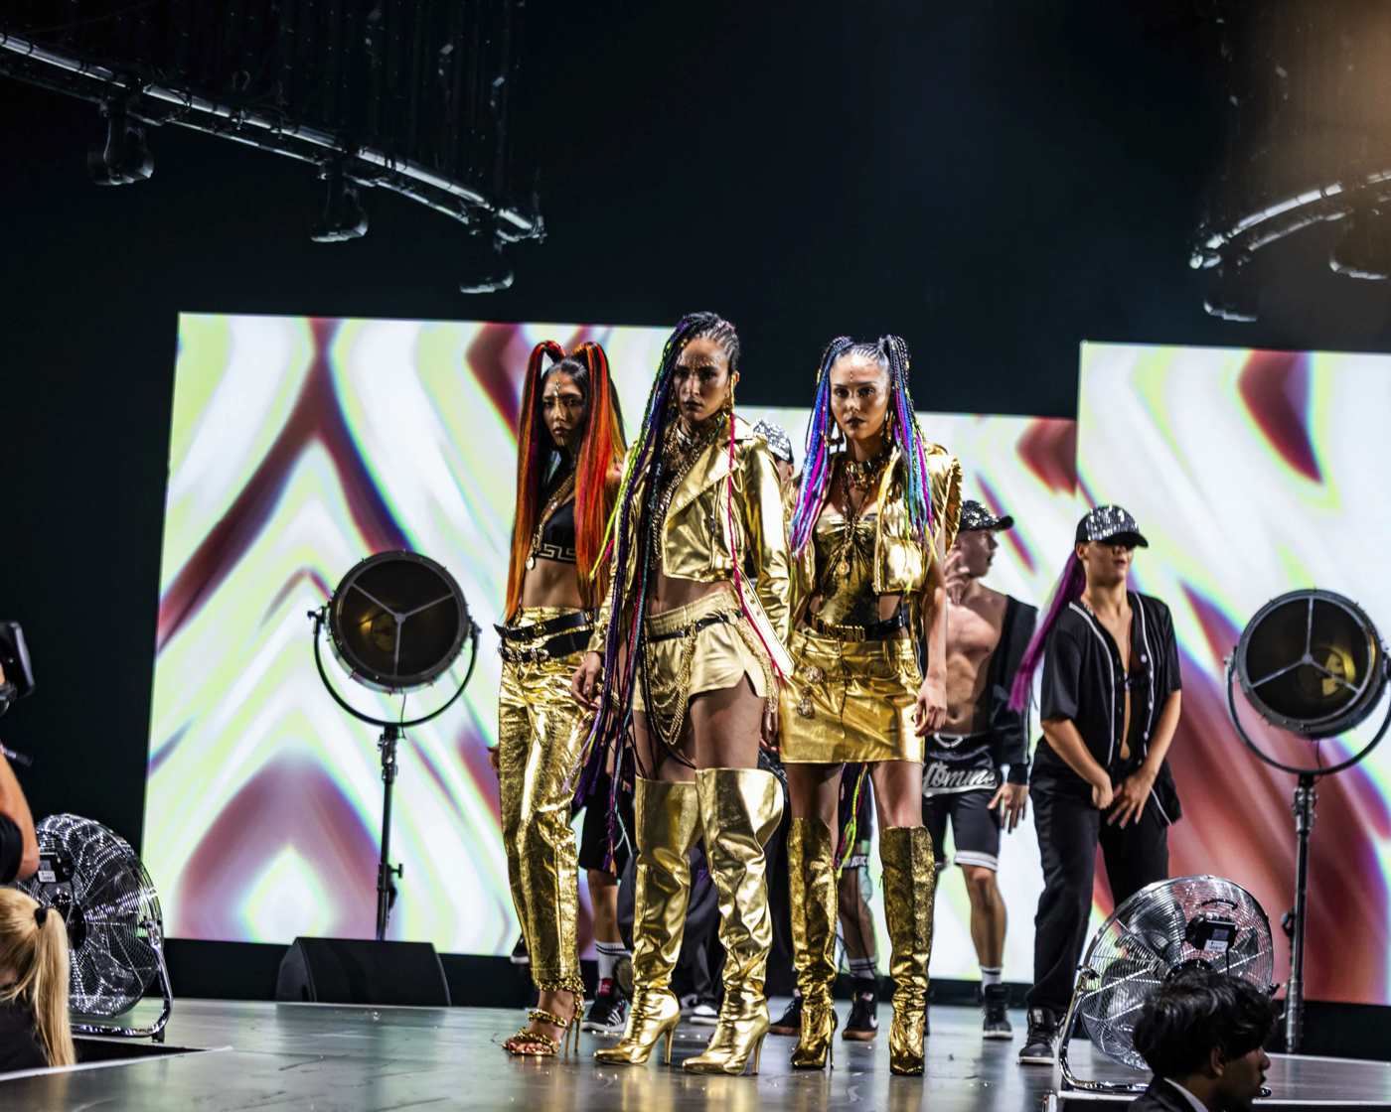
Use a visual sequence to carry the story from atmosphere to detail.

Recommended Sequence
- Full-bleed hero image with the project title and a two-sentence introduction
- Large UK Grand Final image followed by the Think strategy copy
- Two image-led Create panels showing the different London and Dublin experiences
- Wide Deliver image with the four-hour strike result as the main proof point
- Six to twelve image gallery with minimal captions and no repeated views
- Short closing copy followed by service links

02 HERO AND INTRODUCTION

Hero And Introduction
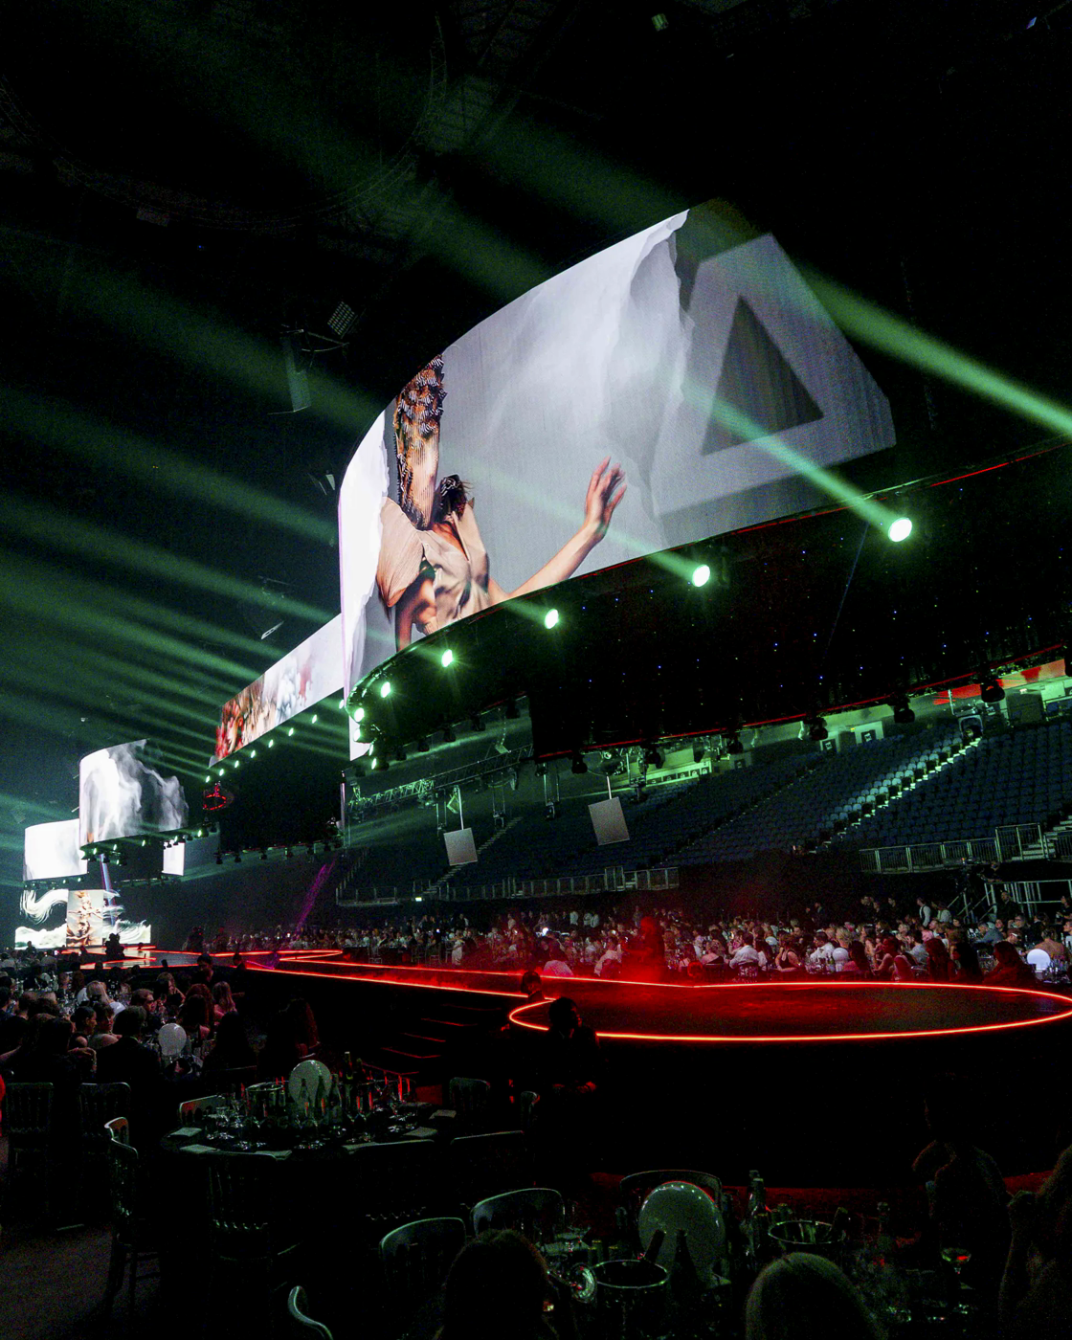
Use this portrait image as a full-height or near full-height opening visual on desktop.
Delivering a Platinum Anniversary Production Celebrating 70 Years of L'Oreal Colour Trophy
For the 70th anniversary of L'Oreal Colour Trophy, we developed two distinctive final experiences in London and Dublin, linked by a single creative vision rooted in colour, creativity and the history of the competition.

Layout Notes
- Allow the image to occupy 65 to 80 percent of the opening viewport.
- Place the headline in a quiet area of the image or immediately below it on a plain background.
- Keep the introduction to two or three lines on desktop and four to five lines on mobile.

03 THINK

Think Event Strategy
Use a wide venue image before the strategy copy so the reader understands the scale first.
L'Oreal Colour Trophy 2026 marked the 70th anniversary of one of the hair industry's most prestigious competitions, recognising creativity, innovation and excellence across the UK and Ireland.
Inspired by the Chroma theme, we created two experiences for the UK Grand Final at The O2, London and the Ireland Final in Dublin. Each was shaped around its venue, audience and technical environment, while both remained connected to the same creative direction.
We worked closely with L'Oreal's creative production teams and Encore APAC's Design Studio to develop an approach that could be adapted across regions without losing the character of either event.
Services
- Creative production support
- Experience and production planning
- Technical production strategy
- Cross-regional collaboration
- Venue and technical feasibility planning

04 CREATE

Create Creative and Content
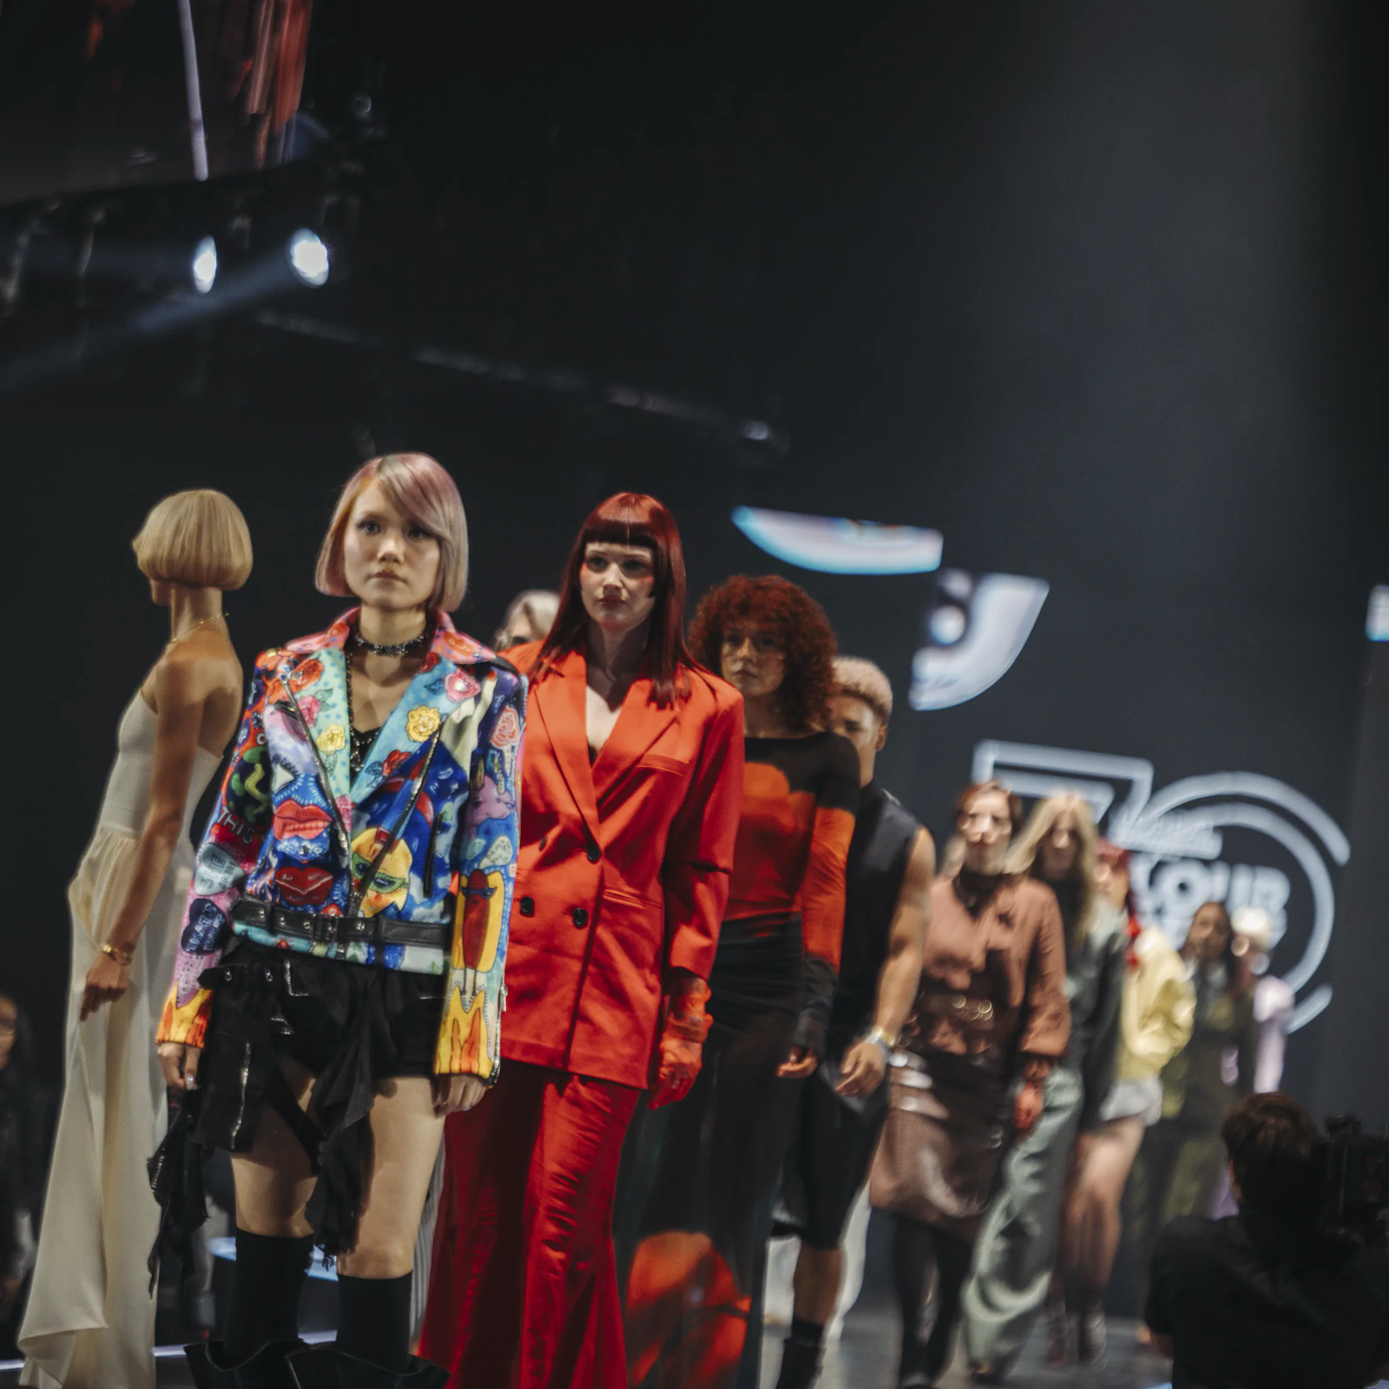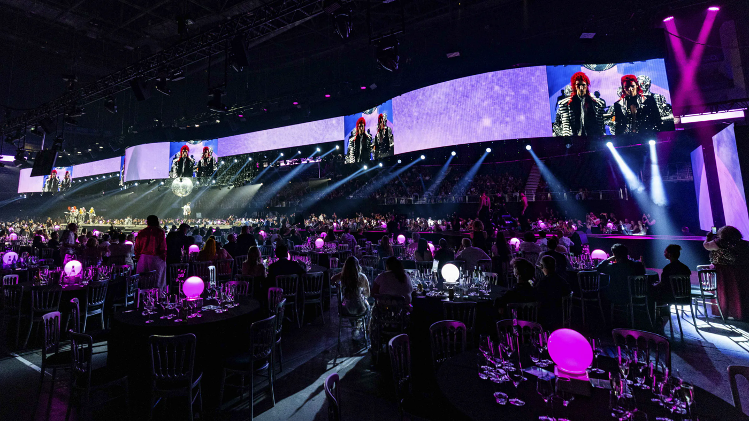
Use a three-image sequence for the Create section; let the images do the comparison work.

UK Grand Final
For the UK Grand Final, the traditional competition format was reimagined around an ambitious 50 m catwalk and 360 degree in-the-round stage, placing finalists at the centre of the experience. Dynamic lighting, video, lasers and special effects created an immersive setting for the competition and its celebration of creativity and craftsmanship.

Ireland Final
For the Ireland Final, a bespoke black gloss thrust stage brought models further into the audience. Venue branding, a custom judging system and an interactive foil selfie booth completed the experience.
Both productions followed the Chroma creative vision while reflecting the character and practical requirements of their venues.
Services
- Stage design
- Lighting design
- Video and content design
- Special effects and laser design
- Venue branding and environmental design
- Bespoke interactive experience design
- Custom judging system development

05 DELIVER

Deliver Technical Production
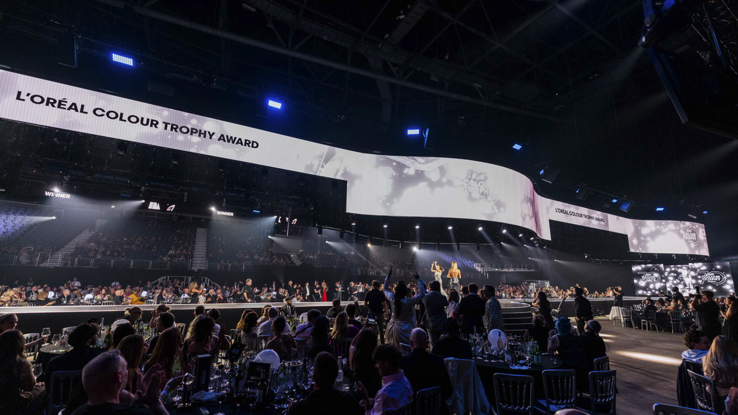
Use a wide technical image to make the delivery story feel concrete and operational.
Full production removed within four hours
The scale and complexity of the productions required extensive pre-production and technical coordination. At The O2, equipment was prepared in advance, rigging requirements were optimised and the teams worked closely with the venue to deliver the ambitious in-the-round production within a demanding schedule.
Across London and Dublin, Encore combined creative design, technical expertise and local venue knowledge to deliver two distinctive productions for L'Oreal Colour Trophy's Platinum anniversary.
Services
- Full technical production
- Stage build
- Lighting production
- Audio production
- Video production and content management
- Rigging and infrastructure management
- Technical production management
- Venue coordination

06 GALLERY

Gallery Direction
Use the gallery as the emotional finish to the page. It should be generous, irregular and image-led, with only enough text to identify the moment. Build it as a masonry grid or full-width filmstrip rather than a row of equal cards.
Gallery sequence one: people and performance.
Gallery sequence two: scale, audience and screen content.

Gallery Rules
- Use six to twelve images on the page, depending on the final page length.
- Mix wide, portrait and detail crops so the scroll has a changing rhythm.
- Avoid using several near-identical views of the same stage moment.
- Confirm the final Ireland Final image coverage before publishing the regional story.
07 HANDOFF

Image And Content Handoff
The source library contains 82 RGB event photographs. The web-ready versions are in the web-optimised folder beside the originals. The selected assets below are starting points for the layout; the wider set can support a larger gallery after final design approval.
Asset | Use | Suggested alt text
loreal crops-100.webp | Hero banner | Curved venue screens show colour-led visuals above the audience.
loreal crops-120.webp | UK feature image | The in-the-round catwalk and circular stage glow red inside The O2.
loreal crops-141.webp | UK overview | The Colour Trophy catwalk sits at the centre of the audience at The O2.
loreal crops-159.webp | Performance detail | Models perform on stage against large colour-led screens.
loreal crops-160.webp | Closing gallery image | A wide view of the production, audience and overhead video system.

Web Delivery
All 82 photographs are exported as WebP files with their original aspect ratios preserved. Each file is capped at a 2,400 px maximum dimension, encoded at quality 82 and stripped of unnecessary metadata. The optimised set is approximately 43 MB in total, compared with approximately 3.0 GB for the source PNGs.
Serve the images with lazy loading below the fold, explicit width and height attributes to prevent layout shift, and CSS cropping only where a component needs a fixed aspect ratio. If the CMS supports responsive derivatives, generate 800 px, 1,600 px and 2,400 px variants from the optimised masters.

Primary Asset Location
OneDrive_1_13-09-2026/web-optimised

